Software Requirements Specification
SRS

Version 2.0

VIPER TEAM (Team#6)

Name | Stu ID#
Abdulrahman Al-Thubaiti | 245406
Anas Al-Hasani | 245050
Faisal Al-Ghamdi | 237263
Mohammed Al-Mathami | 245040
Nasser Al-Al-Khaldi | 226286
Abdullah Al-Jallal | 231945

Revision History
Date | Version | Description | Author
26/Nov/2008 | 0.1 | - Initializing the SRS Document  -writing the introduction | Abdulrahman Al-Thubaiti
29/Nov/2008 | 1.0 | -complete SRS Document. | VIPER team members
20/Dec/2008 | 1.1 | 1- In the UCs discretion the precondition and the first step in the UC discretion are not the same as well as the some of Branching Action need to be changed as it is explained in the meeting.  2- Adding the logical DB section which is the tables that we have in our system.  3- Adding UC diagram into the appendix section as a last thing in the report. | Mohammad AlMathami  Faisal Al-Ghamdi
20/Dec/2008 | 1.2 | 1- Modifying and adding in Communication interface.  2- Modify and improve format document. | Anas Al-Hasani
20/Dec/2008 | 2.0 | 1. Adding Change Management Process  2. Finalizing the SRS and release v2.0 | Abdulrahman Al-Thubaiti

Table of Contents
1. Introduction……………………………………………………………………….…4
1.1 Purpose ……………………………………………………………….……..4
1.2 Scope………………………………………………………………….……..4
1.3 Definitions, Acronyms and Abbreviations ……………………………….…4
1.4 References …………………………………………………………………..5
1.5 Overview ……………………………………………………………………5
2. Overall Description…………………………………………………………….……5
2.1 Product Perspective………………………………………………………….7
2.2 Product Functions …………………………………………………………...8
2.3 User Characteristics …………………………………………………………8
2.4 Constraints ……………………………………………………………….….8
2.5 Assumptions & Dependencies ………………………………………………8
2.6 Apportioning of Requirements………………………………………………8
3. Specific Requirements ……………………………………………………………...8
3.1 Interface Requirements ……………………………………………….……..8
3.1.1 User Interfaces …………………………………………………………..9
3.1.2 Hardware Interfaces ………………………………………………..…..28
3.1.3 Software Interfaces …………………………………………………..…28
3.1.4 Communication Interfaces …………………………………………...…28
3.2 Functional Requirements ………………………………………………...…29
3.3 Performance Requirements …………………………………………...……85
3.4 Logical Database Requirements…………………………………………….85
3.5 Design Constraints……………………………………………………...…..85
3.6 Software System Attributes…………………………………………………85
3.6.1 Reliability……………………………………………………………….85
3.6.2 Availability ……………………………………………………………..85
3.6.3 Security …………………………………………………………………86
3.6.4 Maintainability…………………………………………………………..86
3.6.5 Portability ……………………………………………………………….86
4. Change Management Process……………………………………. ………………….86
Appendix……………………………………………………………………………….87
Use Case Diagrams………………..…………………………………………………….87

Software Requirements Specification

Introduction

Purpose
The purpose of this document is to fully describe the external behavior of the SCM system in terms of functional requirements. It also describes the nonfunctional requirements such as usability, availability, security, maintainability and reliability. In addition, it specifies the design constraints and standards that are needed to be applied on SCM.

Scope
This document represents specification of the SCM system requirements. It serves as the baseline document on which the subsequent software development life cycle phases are built.

Definitions, Acronyms and Abbreviations
Term | Description
SYSTEM | Supply Chain Management Software.
KFUPM | King Fahad University of Petroleum and Minerals
SCM | Supply Chain Management
STD | State Transition Diagram
SRS | Software Requirements Specification
ERP | Enterprise Resource Planning

References
The references of this document are:
- SCM Software Requirements Specification document v.1.2.
- Use Case & STD Documentation v1.5
- SCM Conceptual Class Model and Sequence Diagram document v.2.0
- SCM Screen layouts document v.1.2.
- SWE 417-SRS Template-USE

Overview
This SRS document is organized as flows:

→ Overall description of SCM which include product perspective, product functions, SCM’s user characteristics, constraints, assumptions & dependencies and apportioning of requirements.

→ Specific Requirements which include , interface requirements, functional requirements, performance requirements, logical database requirements, design constraints and software system attributes.

→ Change management process.

2. Overall Description

2.1 Product Perspective:
The perspective of product conduct in delivering Ejada company products like IT products, Business Consultation and other IT service in fast way and less cost than other alternative way. There are other well known SCM systems from Oracle and SAP, they are used in big companies and connecting with other systems but with the same main functionality that is provided by our SCM. Our system scope is limited by Ejada and there requests.
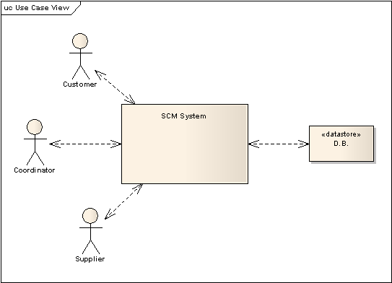

2.2 Product Functions

Ejada SCM will:
- Provide a simple Customer service management process
- Determine mutually satisfying goals between organization and customers
- Establish and maintain customer rapport
- Produce positive feelings in the organization and the customers
- Maintain Procurement process
- Manage Product development and commercialization
- Coordinate with customer relationship management to identify customer-articulated needs
- select materials and suppliers in conjunction with procurement
- Develop production technology in manufacturing flow to manufacture and integrate into the best supply chain flow for the product/market combination.
- Maintain Manufacturing flow management process
- Manage Physical distribution
- Maintain Outsourcing and Partnerships
- Maintain Measurement Performance
- Maintain Cost Performance
- Maintain Customer Service Performance
- Maintain Productivity measures Performance
- Maintain Asset measurement Performance
- Maintain Quality Performance

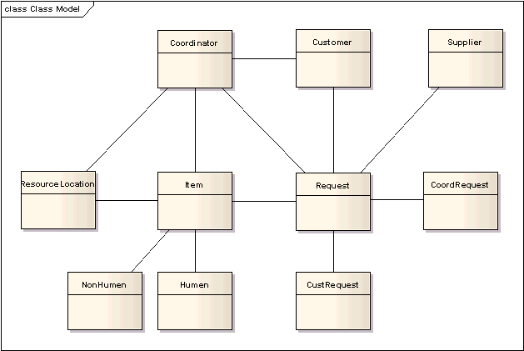

2.3 User Characteristics

The users are Ejada’s employees, customers and suppliers. It considers that they have the high school level or higher and they can read and write in English with basic knowledge of using computer programs.

2.4 Constraints

The system has many constraints. For example, the system must be web-based and all tools must be compliant with .Net technologies, i.e., We must use ASP.NET and C# as programming language and MS SQL as DBMS. We are also constrained with Ejada's framework and the system will later be integrated with other two modules in the framework. Ejada has some programming standards that we must commit to.

2.5 Assumptions & Dependencies

We assume that the server machine of the system has a suitable Microsoft OS. This machine has a connection to internet.

2.6 Apportioning of Requirements

Our SCM system requires including all requirements prior to the first delivery.

3. Specific Requirements

3.1 Interface Requirements

3.1.1 User Interfaces
The system is a web base system so, it will interact with its users with web components interface. The users move through pages containing activities or direction to some other activities.
The system interface will looks like following:



- intro page to the system. Direct link to login page.

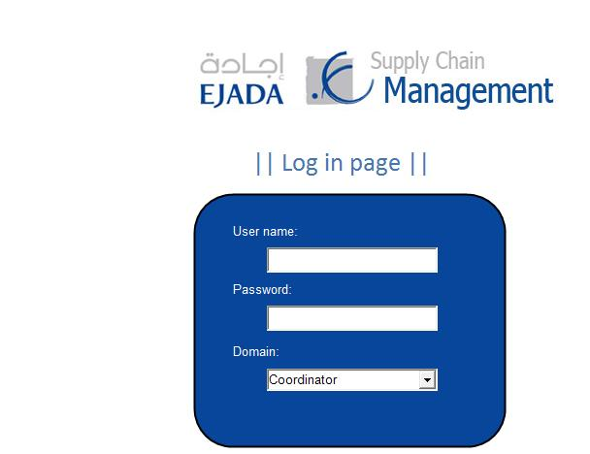

- Log in page contain 2 text fields and 1 list box : username, password and domain.
- The user should write his/her username, password and select in which domain he/she is.
- Domain list box has 3 choices [ coordinator, costumer and supplier ].
- After the user click send or hit enter button the system will direct the user to its domain if he/she is in coordinator, costumer or supplier section.
- If username or password is wrong the system will direct the user to an error page.

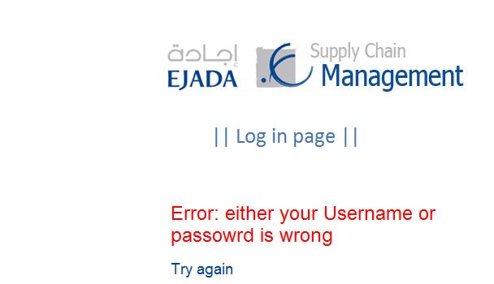

- if the information provided by the user is wrong this page will appear to him/her.
- User can click on [ Try again ] link, so he/she can try to log in again.

→ Coordinator section:
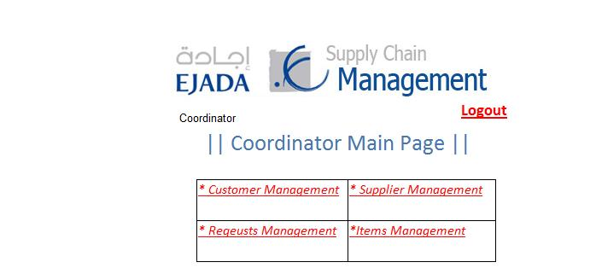

- First page in the coordinator domain.
- User can select customer, supplier, requests or items management section.
- User can click on [ Logout ] link, so that he/she logged out from the system.

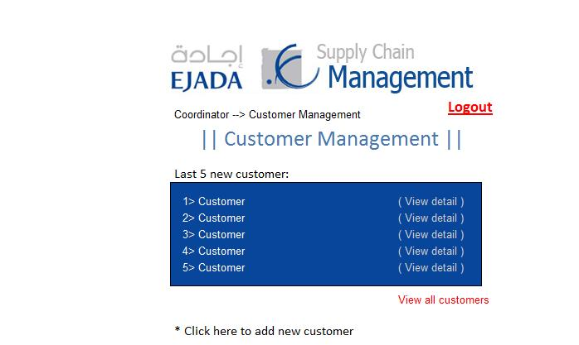

- Customer management section in coordinator domain.
- This page display the last 5 new customer.
- User can click on [ view detail ] for more information about a customer.
- User can click on [ view all customers ] link, he/she will directed to page will full customer list.
- User can click on [ add new customer ] link, to add a new customer to the system.
- Navigation bar under the banner of the system that allow user to navigate through pages.
- User can click on [ Logout ] link, so that he/she logged out from the system.

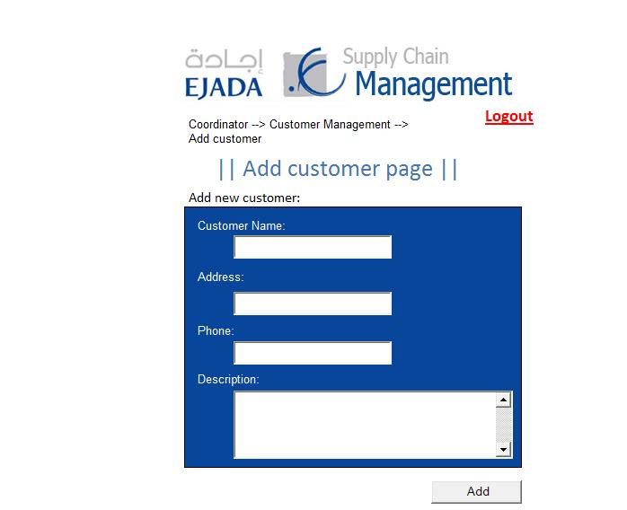

- add customer page contain 4 information fields.
- After writing all the information, user will click on [ add ] button to add the customer to the system.
- Navigation bar under the banner of the system that allow user to navigate through pages.
- User can click on [ Logout ] link, so that he/she logged out from the system.

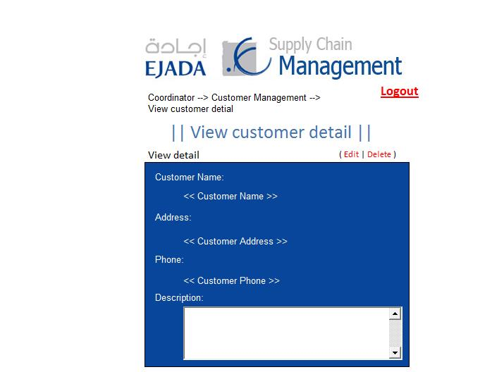

- when click on [ view detail ] of some customer. The system will direct the user to view customer details.
- Two link appear above the box, edit and delete link. This will perform on the current page.
- Navigation bar under the banner of the system that allow user to navigate through pages.
- User can click on [ Logout ] link, so that he/she logged out from the system.

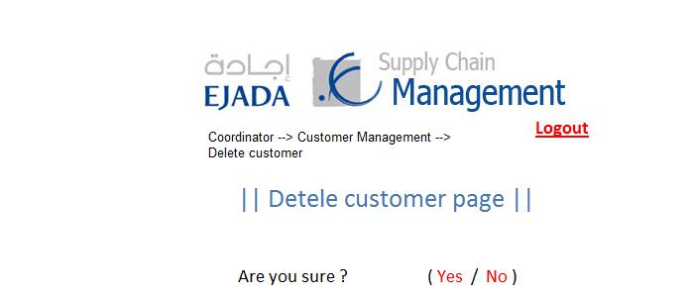
- page to conform the deletion. User must click on either yes or no.

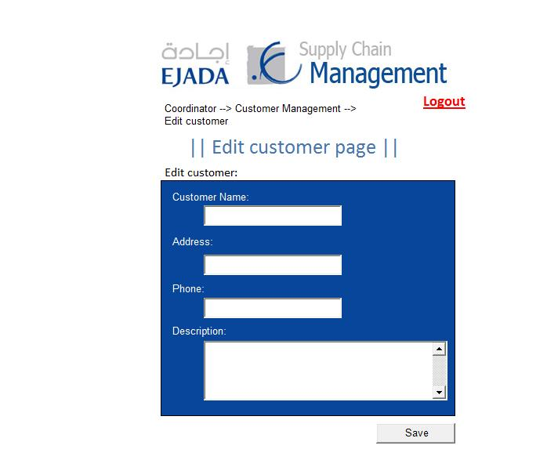

- edit customer page contain 4 information fields.
- After editing all the information, user will click on [ edit ] button to edit the customer information.
- Navigation bar under the banner of the system that allow user to navigate through pages.
- User can click on [ Logout ] link, so that he/she logged out from the system.

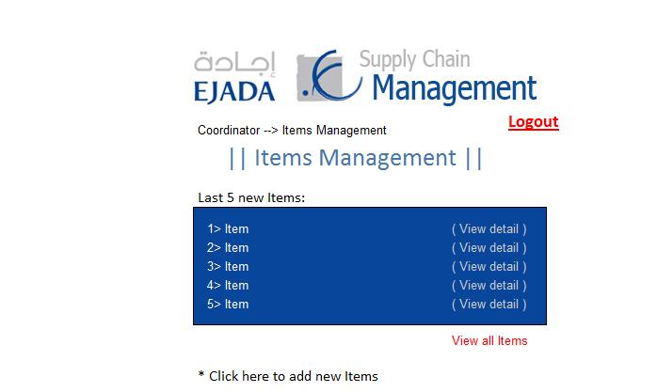

- Items management section in coordinator domain.
- This page display the last 5 new Items.
- User can click on [ view detail ] for more information about item.
- User can click on [ view all Items ] link, he/she will directed to page will full items list.
- User can click on [ add new Items ] link, to add a new item to the system.
- Navigation bar under the banner of the system that allow user to navigate through pages.
- User can click on [ Logout ] link, so that he/she logged out from the system.

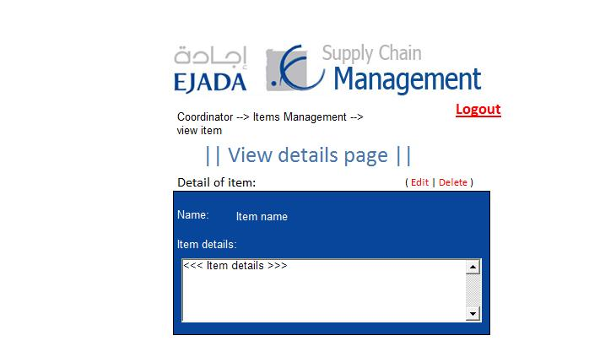

- when click on [ view detail ] of item. The system will direct the user to view item details.
- Two link appear above the box, edit and delete link. This will perform on the current page.
- Navigation bar under the banner of the system that allow user to navigate through pages.
- User can click on [ Logout ] link, so that he/she logged out from the system.

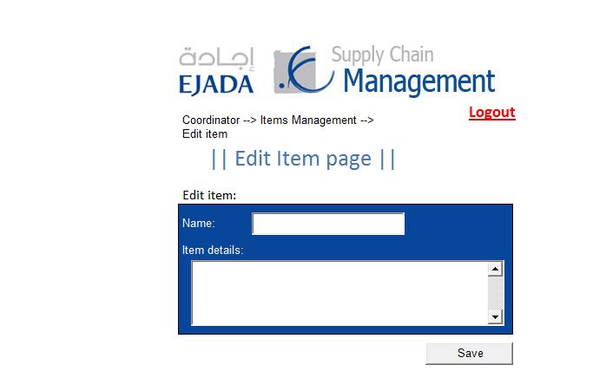

- edit item page contain 2 information fields.
- After editing all the information, user will click on [ save ] button to edit the item information.
- Navigation bar under the banner of the system that allow user to navigate through pages.
- User can click on [ Logout ] link, so that he/she logged out from the system.

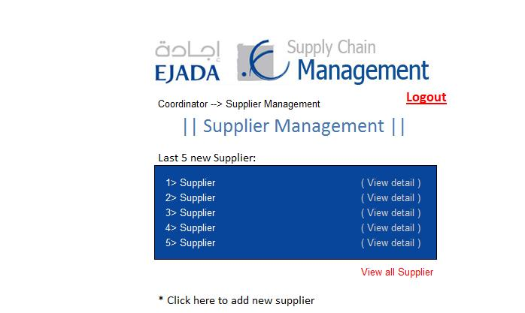

- Supplier management section in coordinator domain.
- This page display the last 5 new supplier.
- User can click on [ view detail ] for more information about a supplier.
- User can click on [ view all supplier ] link, he/she will directed to page will full supplier list.
- User can click on [ add new supplier ] link, to add a new supplier to the system.
- Navigation bar under the banner of the system that allow user to navigate through pages.
- User can click on [ Logout ] link, so that he/she logged out from the system.

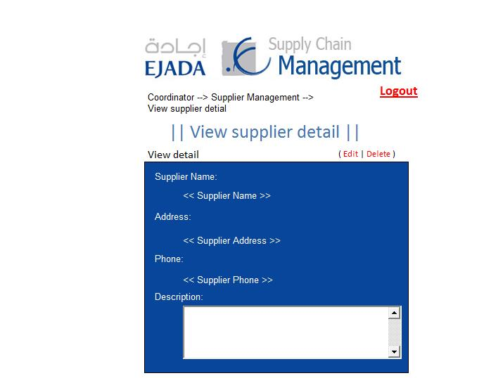

- when click on [ view detail ] of supplier. The system will direct the user to view supplier details.
- Two link appear above the box, edit and delete link. This will perform on the current page.
- Navigation bar under the banner of the system that allow user to navigate through pages.
- User can click on [ Logout ] link, so that he/she logged out from the system.

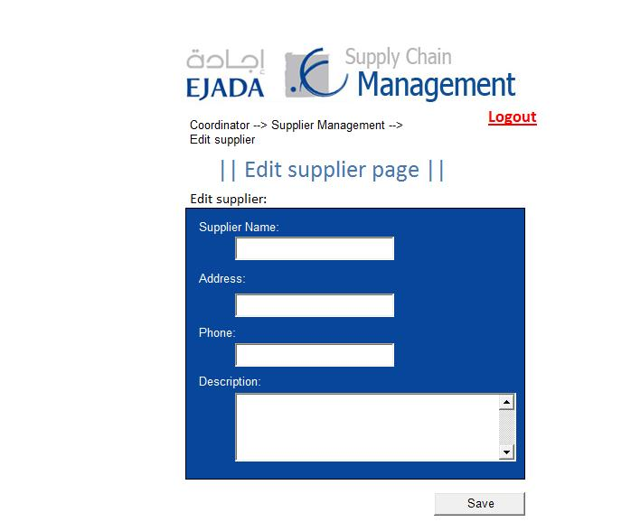

- edit supplier page contain 4 information fields.
- After editing all the information, user will click on [ edit ] button to edit the supplier information.
- Navigation bar under the banner of the system that allow user to navigate through pages.
- User can click on [ Logout ] link, so that he/she logged out from the system.

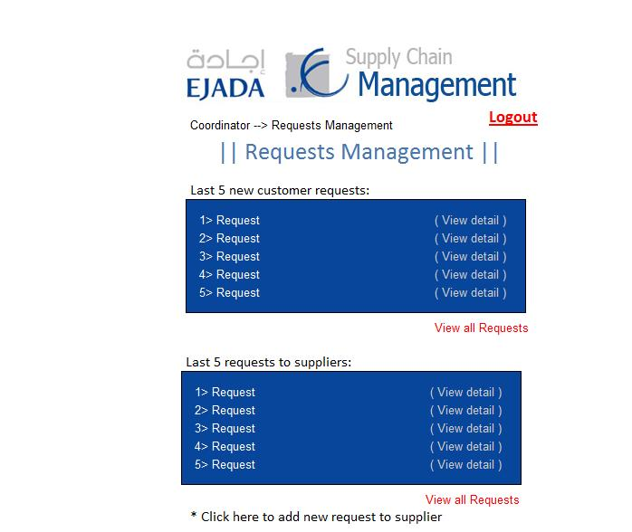

- Requests management section in coordinator domain.
- This page display the last 5 new customer requests and the last 5 requests to suppliers.
- User can click on [ view detail ] for more information about a requests.
- User can click on [ view all Requests ] link, he/she will directed to page will full customer list.
- User can click on [ add new Requests ] link, to add a new requests to the system.
- Navigation bar under the banner of the system that allow user to navigate through pages.
- User can click on [ Logout ] link, so that he/she logged out from the system.

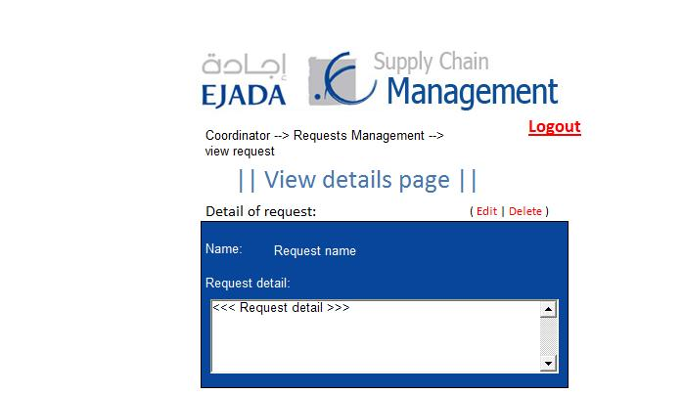
- when click on [ view detail ] of request. The system will direct the user to view request details.
- Two link appear above the box, edit and delete link. This will perform on the current page.
- Navigation bar under the banner of the system that allow user to navigate through pages.
- User can click on [ Logout ] link, so that he/she logged out from the system.

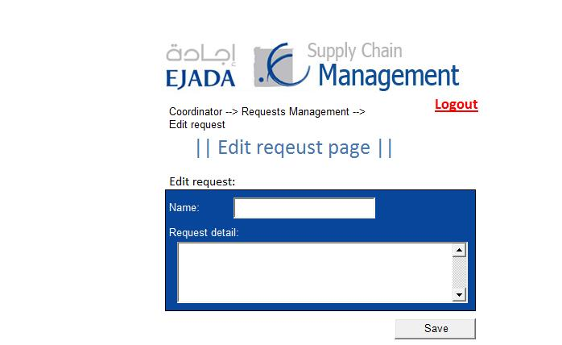

- edit request page contain 2 information fields.
- After editing all the information, user will click on [ save ] button to edit the request information.
- Navigation bar under the banner of the system that allow user to navigate through pages.
- User can click on [ Logout ] link, so that he/she logged out from the system.

- Customer section:

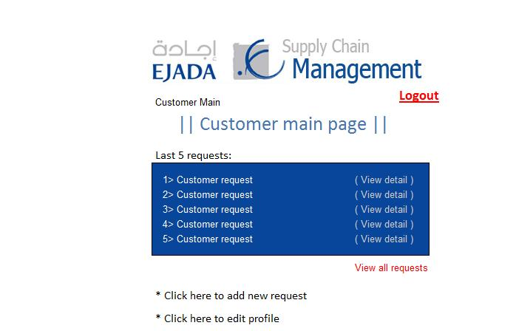

- The main page in customer domain.
- This page display the last 5 new requests.
- User can click on [ view detail ] for more information about request.
- User can click on [ view all requests ] link, he/she will directed to page will full requests list.
- User can click on [ add new request ] link, to add a new requests to the system.
- User can edit his/her profile, a link [ edit profile ] there to do so.
- Navigation bar under the banner of the system that allow user to navigate through pages.
- User can click on [ Logout ] link, so that he/she logged out from the system.

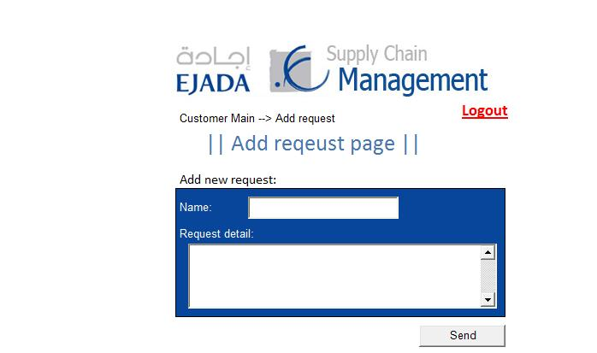

- add request page contain 2 information fields.
- After writing all the information, user will click on [ send ] button to add the request information.
- Navigation bar under the banner of the system that allow user to navigate through pages.
- User can click on [ Logout ] link, so that he/she logged out from the system.

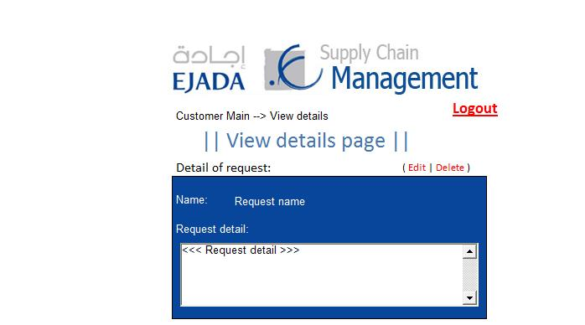

- when click on [ view detail ] of request. The system will direct the user to view request details.
- Two link appear above the box, edit and delete link. This will perform on the current page.
- Navigation bar under the banner of the system that allow user to navigate through pages.
- User can click on [ Logout ] link, so that he/she logged out from the system.

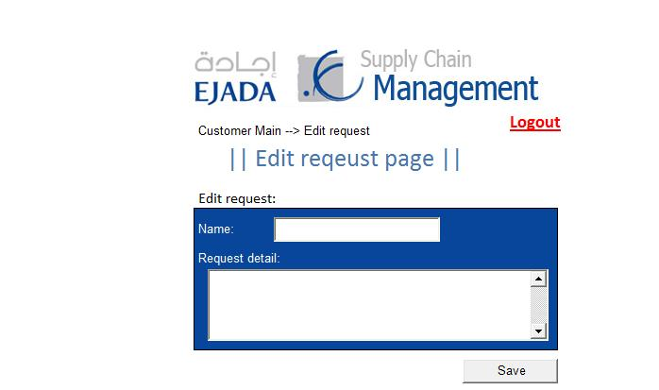

- edit request page contain 2 information fields.
- After editing all the information, user will click on [ save ] button to edit the request information.
- Navigation bar under the banner of the system that allow user to navigate through pages.
- User can click on [ Logout ] link, so that he/she logged out from the system.
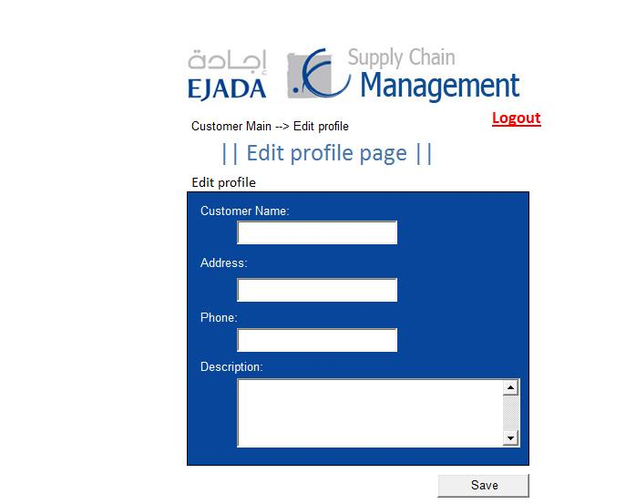

- edit customer profile contain 4 information fields.
- After editing all the information, user will click on [ save ] button to edit the customer profile information.
- Navigation bar under the banner of the system that allow user to navigate through pages.
- User can click on [ Logout ] link, so that he/she logged out from the system.

- Supplier section:

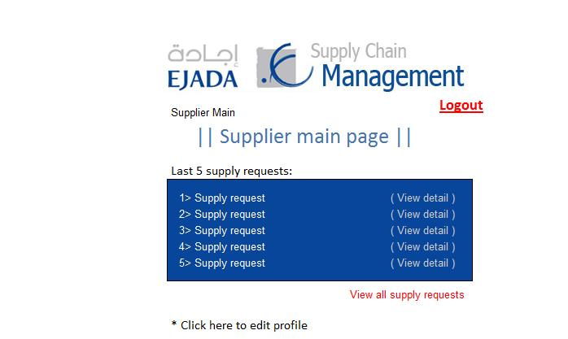

- The main page in supplier domain.
- This page display the last 5 new requests.
- User can click on [ view detail ] for more information about request.
- User can click on [ view all supply requests ] link, he/she will directed to page will full requests list.
- User can edit his/her profile, a link [ edit profile ] there to do so.
- Navigation bar under the banner of the system that allow user to navigate through pages.
- User can click on [ Logout ] link, so that he/she logged out from the system.

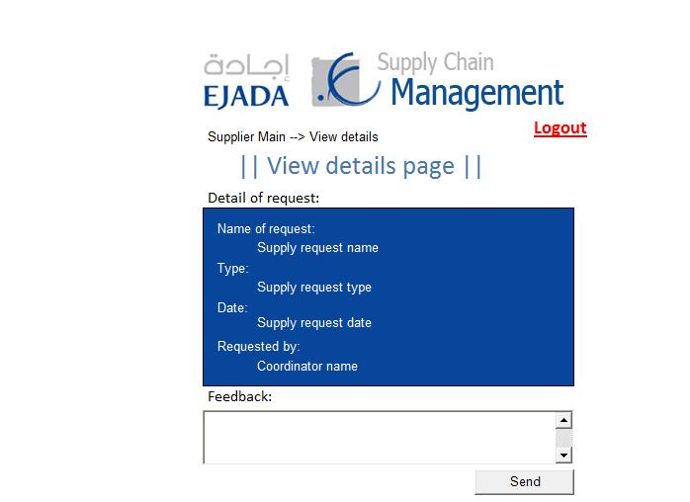

- when click on [ view detail ] of request. The system will direct the user to view request details.
- Two link appear above the box, edit and delete link. This will perform on the current page.
- The page contain a feedback box, the supplier may send his feedback about the request.
- Navigation bar under the banner of the system that allow user to navigate through pages.
- User can click on [ Logout ] link, so that he/she logged out from the system.

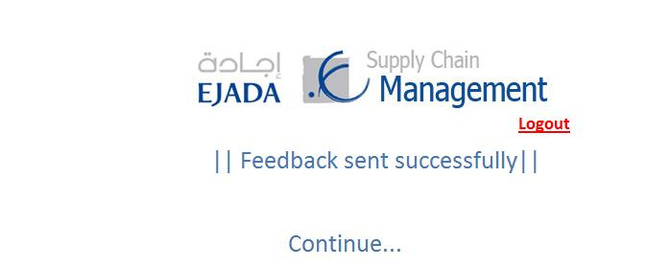

- Redirected page after sending the feedback.

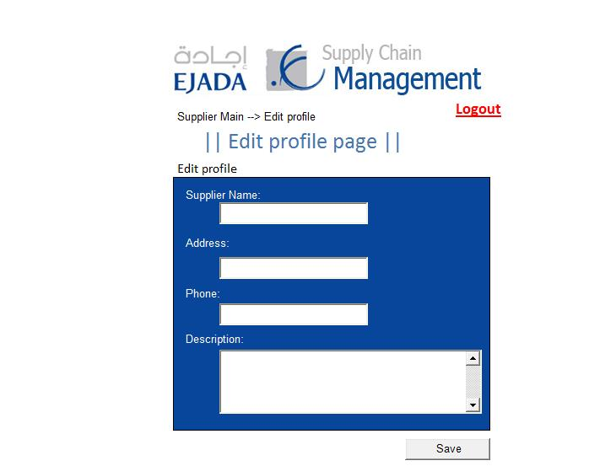
- edit supplier profile contain 4 information fields.
- After editing all the information, user will click on [ save ] button to edit the supplier profile information.
- Navigation bar under the banner of the system that allow user to navigate through pages.
- User can click on [ Logout ] link, so that he/she logged out from the system.

3.1.2 Hardware Interfaces

The system has no hardware interface requirements.

3.1.3 Software Interfaces

Name | SQL- Server
Mnemonic | SQL-DB
Specification
Number
Version  Number | Version 7.0.1
Source | http://www.microsoft.com/sqlserver/2008/en/us/default.aspx
Purpose of  Interfacing | The system must use SQL server as its database.

Name | Internet Explorer
Mnemonic | IE
Specification
Number
Version  Number | Version 6 and Version 7
Source | http://www.microsoft.com/windows/products/winfamily/ie/default.mspx
Purpose of  Interfacing | The user should use this browser, so that he can display the system and work on it.

Name | Mozilla firefox
Mnemonic | Firefox
Specification
Number
Version  Number | Version 2 and Version 3
Source | http://www.mozilla.com/en-US/firefox/
Purpose of  Interfacing | The user should use this browser, so that he can display the system and work on it.

3.1.4 Communication Interfaces

The SCM system will use TCP/IP as the main communication protocol trough internet/network.

Also, it might communicate with external systems in the future, such as customer relation management system and HR systems. The scope of our system does not require to interact with other interfaces but it can be customized.
3.2 Functional Requirements

3.2.1.1 Manage Requests

USE CASE # 1 | Manage Requests
Goal in Context | The main requests management page that coordinator will manage all request from customer or to suppliers
Scope & Level | Company, Summary
Preconditions | -Must the coordinator login
Success End Condition | - The coordinator can manage his request can add ,view or edit his requests
Failed End Condition | - Login in failed  - There is No suppliers for his requests
Primary,  Secondary Actors | Coordinator , Supplier, Customer
Trigger
DESCRIPTION | Step | Action
 | 1 | The coordinator press “Manage Requests”
 | 2 | The coordinator use any function.
 | 3 | The coordinator will manage all requests function.
EXTENSIONS | Step | Branching Action
 |  | - "Error!" message.
SUB-VARIATIONS |  | Branching Action
 | 1 | Coordinator may use phone to request from suppliers

RELATED INFORMATION | Manage Requests
Priority: | Top
Performance
Frequency
Channels to actors
OPEN ISSUES | What is the coordinator cannot manage requests?  What is the coordinator cannot use requests functions?
Due Date | Release 1.0
...any other
management
information...
Superordinates | Login
Subordinates | Add Request , View Requests

3.2.2.1 Add Request

USE CASE #2 | Add Request
Goal in Context | Coordinator can add new request and send it to his supplier
Scope & Level | Company , Summary
Preconditions | -Must the coordinator login
Success End Condition | - The coordinator can add new request.  - The request sent to supplier
Failed End Condition | - Login in failed  - There is No suppliers for his requests or send error
Primary,  Secondary Actors | Coordinator , Supplier
Trigger | When the coordinator needs to add new request.
DESCRIPTION | Step | Action
 | 1 | The coordinator press “Add Request”
 | 2 | The coordinator fills the request form.
 | 3 | The coordinator will send the request to supplier
EXTENSIONS | Step | Branching Action
 | 1a | - "Error!" message
SUB-VARIATIONS |  | Branching Action
 | 1 | Coordinator may use phone to request from suppliers

RELATED INFORMATION | Add Request
Priority: | Top
Performance | 10 minutes for request, 2 days until accept
Frequency | 10/day
Channels to actors | not yet determined
OPEN ISSUES | What is the coordinator cannot add new requests?
Due Date | Release 1.0
...any other
management
information...
Superordinates | Requests Management
Subordinates | None

3.2.2.2 Sequence Diagram
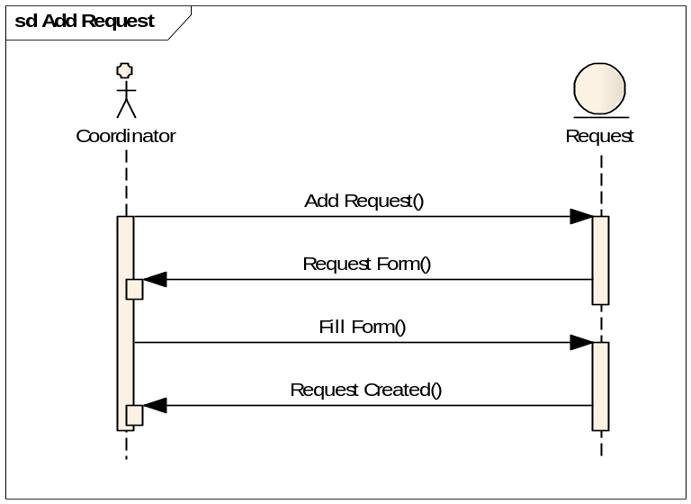

3.2.3.1 View Requests

USE CASE #3 | View Requests
Goal in Context | Coordinator issues requests , coordinator can show all requests that sent his supplier or that came from his customer
Scope & Level | Company , Summary
Preconditions | -Must the coordinator login
Success End Condition | - The coordinator can show all requests.
Failed End Condition | - Login in failed  - The coordinator cannot view all requests.
Primary,  Secondary Actors | Coordinator , Supplier, Customer
Trigger | When the coordinator needs to view requests.
DESCRIPTION | Step | Action
 | 1 | The coordinator press “View Requests”
 | 2 | The coordinator view list of requests.
EXTENSIONS | Step | Branching Action
 | 1a | "Error!" message
SUB-VARIATIONS |  | Branching Action
 | 1 | Coordinator may want to see the customers requests only
 | 2 | Coordinator may want to see the requests that sent to suppliers

RELATED INFORMATION | View Requests
Priority: | Top
Performance | 10 seconds to show the list
Frequency | 10/day
Channels to actors | not yet determined
OPEN ISSUES | What is the coordinator cannot view requests?
Due Date | Release 1.0
...any other
management
information...
Superordinates | Manage Requests
Subordinates | View Request Details

3.2.3.2 Sequence Diagram
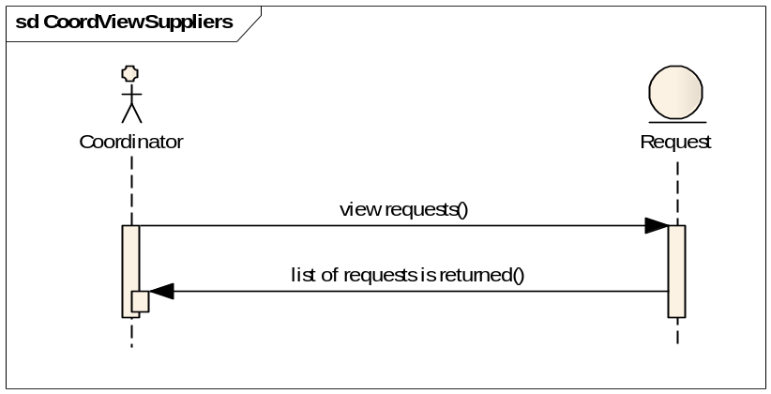
3.2.4.1 View Request Details
USE CASE #4 | View Request Details
Goal in Context | Coordinator can show the details of any request that he chose.
Scope & Level | Company , Summary
Preconditions | -Must the coordinator login
Success End Condition | - The coordinator can show the details of a request.
Failed End Condition | - The coordinator cannot show the details of a request.
Primary,  Secondary Actors | Coordinator , Supplier, Customer
Trigger | When the coordinator need to view the details of a request.
DESCRIPTION | Step | Action
 | 1 | The coordinator press “View Request Details”
 | 2 | The coordinator views the details of a request.
EXTENSIONS | Step | Branching Action
 | 1a | "Error!" message
SUB-VARIATIONS |  | Branching Action

RELATED INFORMATION | View Request Details
Priority: | Middle
Performance | 10 seconds to show the details of a request.
Frequency | 10/day
Channels to actors | not yet determined
OPEN ISSUES | What is the coordinator cannot view the details of a request?
Due Date | Release 1.0
...any other
management
information...
Superordinates | View Requests
Subordinates | Delete Request, Edit Request

3.2.1.2 Sequence Diagram
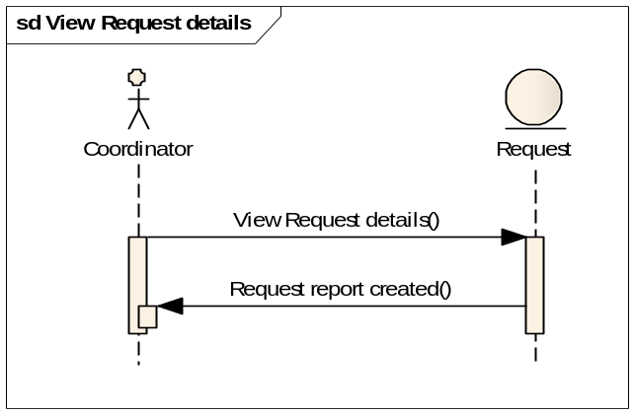

3.2.5.1 Edit Request

USE CASE # 5 | Edit Request
Goal in Context | The Coordinator can edit request and notify his supplier
Scope & Level | Company , Summary
Preconditions | -Must the coordinator login
Success End Condition | - The coordinator can edit exist request.  - The notification will send to supplier.
Failed End Condition | - Login in failed  - The coordinator cannot edit exist request.  - The notification cannot send to supplier.
Primary,  Secondary Actors | Coordinator , Suppliers
Trigger | When the coordinator needs to edit any exist request.
DESCRIPTION | Step | Action
 | 1 | The coordinator press “Edit Request”
 | 2 | The coordinator modifies the request information.
 | 3 | The coordinator will send a notification to supplier
EXTENSIONS | Step | Branching Action
 | 1a | "Error!" message
SUB-VARIATIONS |  | Branching Action
 | 1 | Coordinator may use phone to request from suppliers

RELATED INFORMATION | Edit Request
Priority: | Top
Performance | 10 minutes for edit, on time change
Frequency | 10/day
Channels to actors | not yet determined
OPEN ISSUES | What is the coordinator cannot edit any request?
Due Date | Release 1.0
...any other
management
information...
Superordinates | View Request Details
Subordinates | None

3.2.5.2 Sequence Diagram
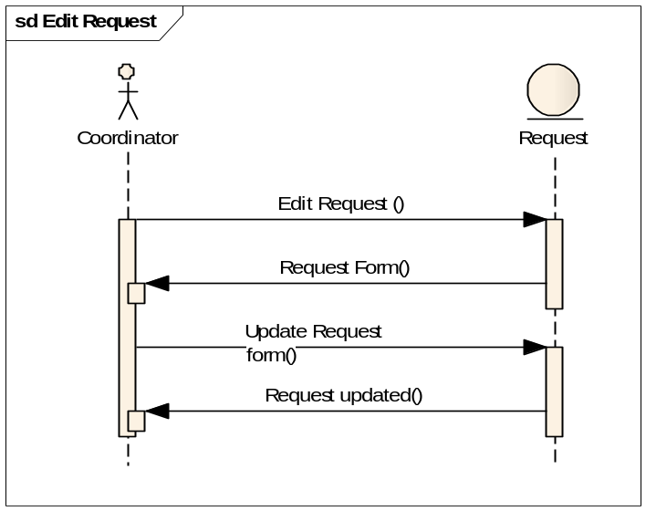

3.2.6.1 Delete Request

USE CASE #6 | Delete Request
Goal in Context | The Coordinator can delete request and notify his supplier
Scope & Level | Company , Summary
Preconditions | -Must the coordinator login
Success End Condition | - The coordinator can delete exist request.  - The notification will send to supplier.
Failed End Condition | - Login in failed  - The coordinator cannot delete exist request.  - The notification cannot send to supplier.
Primary,  Secondary Actors | Coordinator , Suppliers
Trigger | When the coordinator needs to delete any exist request.
DESCRIPTION | Step | Action
 | 1 | The coordinator press “Delete Request”
 | 2 | The information about the request will show.
 | 3 | Press “Delete” to processing the deleting
 | 4 | The coordinator will send a notification to supplier
EXTENSIONS | Step | Branching Action
 | 1a | "Error!" message
SUB-VARIATIONS |  | Branching Action
 | 1 | Coordinator may use phone to delete the request from suppliers

RELATED INFORMATION | Delete Request
Priority:
Performance | 1 minute for delete
Frequency | 10/day
Channels to actors | not yet determined
OPEN ISSUES | What is the coordinator cannot delete requests?
Due Date | Release 1.0
...any other
management
information...
Superordinates | View Request Details
Subordinates | None

3.2.6.2 Sequence Diagram
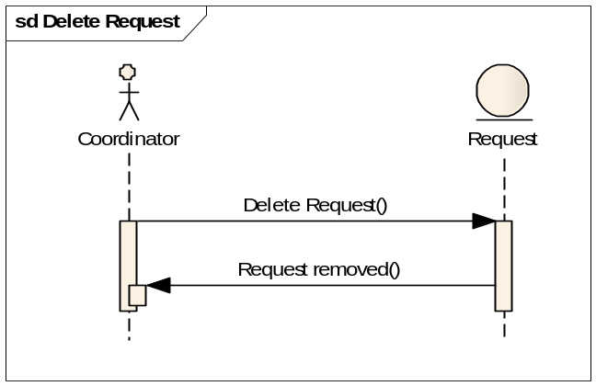

3.2.7.1 Manage Items

USE CASE # 7 | Manage Items
Goal in Context | The main items management page that coordinator will manage the items that he have and may supply to customer
Scope & Level | Company, Summary
Preconditions | -Must the coordinator login
Success End Condition | - The coordinator can manage his items can add ,view or edit his items
Failed End Condition | - Login in failed  - There is No items to manage or supply it
Primary,  Secondary Actors | Coordinator , Supplier, Customer
Trigger
DESCRIPTION | Step | Action
 | 1 | The coordinator press “Manage Items”
 | 2 | The coordinator use any function.
 | 3 | The coordinator will manage all items function.
EXTENSIONS | Step | Branching Action
 | 1a | - "Error!" message
SUB-VARIATIONS |  | Branching Action
 | 1 | Coordinator may use some different items

RELATED INFORMATION | Manage Items
Priority: | Top
Performance | 5 second to show items functions
Frequency
Channels to actors | Not yet determine
OPEN ISSUES | What is the coordinator cannot manage items?  What is the coordinator cannot use items functions?
Due Date | Release 1.0
...any other
management
information...
Superordinates | Login
Subordinates | Add Item , View Items

3.2.8.1 Add Item

USE CASE# 8 | Add Item
Goal in Context | Coordinator can add new items and may supply it to our customer
Scope & Level | Company , Summary
Preconditions | -Must the coordinator login
Success End Condition | - The coordinator can add new item
Failed End Condition | - The coordinator cannot add new item
Primary,  Secondary Actors | Coordinator , Supplier ,Customer
Trigger | When the coordinator needs to add new item.
DESCRIPTION | Step | Action
 | 1 | The coordinator press “Add Item”
 | 2 | The coordinator fills the item form.
 | 3 | The coordinator will save the item.
EXTENSIONS | Step | Branching Action
 | 1a | "Error!" message
SUB-VARIATIONS |  | Branching Action

RELATED INFORMATION | Add Item
Priority: | Top
Performance | 10 minutes for add item
Frequency | 10/day
Channels to actors | not yet determined
OPEN ISSUES | What is the coordinator cannot add new items?
Due Date | Release 1.0
...any other
management
information...
Superordinates | Manage Items
Subordinates | None

3.2.8.2 Sequence Diagram
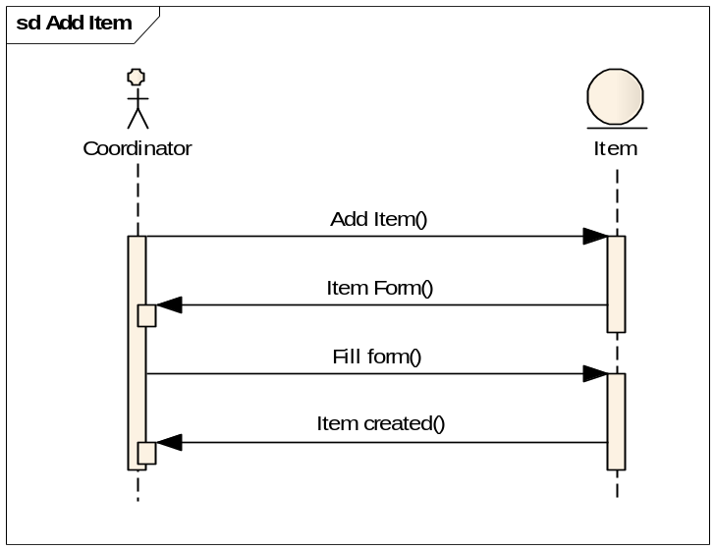

3.2.9.1 View Items

USE CASE # 9 | View Items
Goal in Context | The coordinator can view all items that he have ,that may receive from supplier and may supply it for his customers
Scope & Level | Company , Summary
Preconditions | -Must the coordinator login
Success End Condition | - The coordinator can view all Items.
Failed End Condition | - Login in failed  - The coordinator cannot view all Items.
Primary,  Secondary Actors | Coordinator , Supplier, Customer
Trigger | When the coordinator needs to view all Items.
DESCRIPTION | Step | Action
 | 1 | The coordinator press “View Items”
 | 2 | The coordinator view list of Items
EXTENSIONS | Step | Branching Action
 | 1a | "Error!" message
SUB-VARIATIONS |  | Branching Action
 | 1 | Coordinator may want to see the Items category
 | 2 | Coordinator may want to see the Items that sent to customers

RELATED INFORMATION | View Items
Priority: | Top
Performance | 10 seconds to show the list
Frequency | 10/day
Channels to actors | not yet determined
OPEN ISSUES | What is the coordinator cannot view items?
Due Date | Release 1.0
...any other
management
information...
Superordinates | Manage Items
Subordinates | View Item Details

3.2.9.2 Sequence Diagram
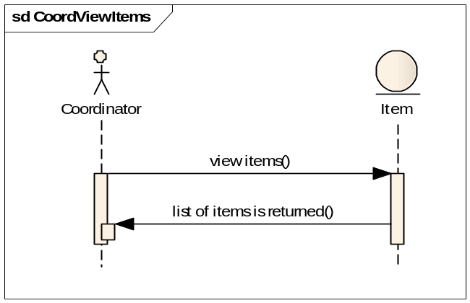

3.2.10.1 View Item Details
USE CASE # 10 | View Item Details
Goal in Context | Coordinator can show the details of any items that he chooses.
Scope & Level | Company , Summary
Preconditions | -Must the coordinator login
Success End Condition | - The coordinator can show the details of an item.
Failed End Condition | - The coordinator cannot show the details of an item.
Primary,  Secondary Actors | Coordinator , Supplier, Customer
Trigger | When the coordinator need to view the details of an item.
DESCRIPTION | Step | Action
 | 1 | The coordinator press “View Item Details”
 | 2 | The coordinator views the details of an item.
EXTENSIONS | Step | Branching Action
 | 1a | "Error!" message
SUB-VARIATIONS |  | Branching Action

RELATED INFORMATION | View Item Details
Priority: | middle
Performance | 10 seconds to show the details of an item.
Frequency | 10/day
Channels to actors | not yet determined
OPEN ISSUES | What is the coordinator cannot view the details of an item?
Due Date | Release 1.0
...any other
management
information...
Superordinates | View Items
Subordinates | Delete Item, Edit Item

3.2.10.2 Sequence Diagram
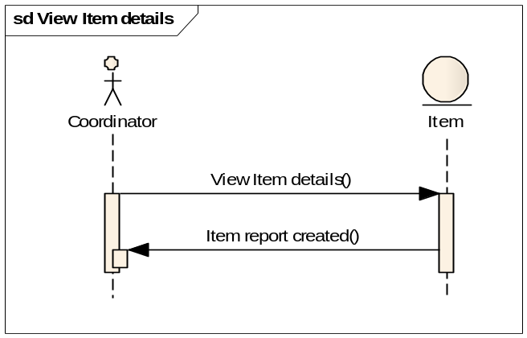

3.2.11.1 Edit Item

USE CASE # 11 | Edit Item.
Goal in Context | The Coordinator can edit item that he want.
Scope & Level | Company , Summary
Preconditions | -Must the coordinator login
Success End Condition | - The coordinator can edit exist item.  - The notification will send to supplier and customer if need.
Failed End Condition | - Login in failed  - The coordinator cannot edit exist item.
Primary,  Secondary Actors | Coordinator , Supplier, Customer
Trigger | When the coordinator needs to edit any exist item.
DESCRIPTION | Step | Action
 | 1 | The coordinator press “Edit Item”
 | 2 | The coordinator modifies the item information.
 | 3 | The coordinator will send a notification to supplier or customer if need.
EXTENSIONS | Step | Branching Action
 | 1a | "Error!" message
SUB-VARIATIONS |  | Branching Action

RELATED INFORMATION | Edit Item
Priority: | Top
Performance | 10 minutes for edit, on time change
Frequency | 10/day
Channels to actors | not yet determined
OPEN ISSUES | What is the coordinator cannot edit any request?
Due Date | Release 1.0
...any other
management
information...
Superordinates | View Items Details
Subordinates | None

3.2.11.2 Sequence Diagram
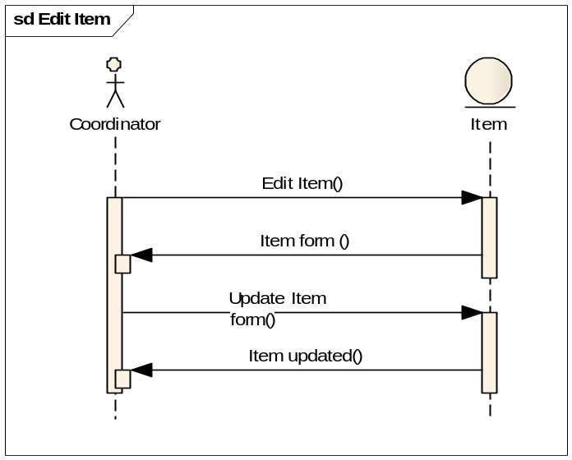

3.2.12.1 Delete Item

USE CASE # 12 | Delete Item
Goal in Context | The Coordinator can delete any item from his list and his supply.
Scope & Level | Company , Summary
Preconditions | -Must the coordinator login
Success End Condition | - The coordinator can delete exist item.
Failed End Condition | - Login in failed  - The coordinator cannot delete exist item.
Primary,  Secondary Actors | Coordinator.
Trigger | When the coordinator needs to delete any exist item.
DESCRIPTION | Step | Action
 | 1 | The coordinator press “Delete Item”
 | 2 | The information about the item will show.
 | 3 | Press “Delete” to processing the deleting
EXTENSIONS | Step | Branching Action
 | 1a | "Error!" message
SUB-VARIATIONS |  | Branching Action

RELATED INFORMATION | Delete Item
Priority:
Performance | 1 minute for delete
Frequency | 10/day
Channels to actors | not yet determined
OPEN ISSUES | What is the coordinator cannot delete an item?
Due Date | Release 1.0
...any other
management
information...
Superordinates | View Item Details
Subordinates | None

3.2.12.2 Sequence Diagram
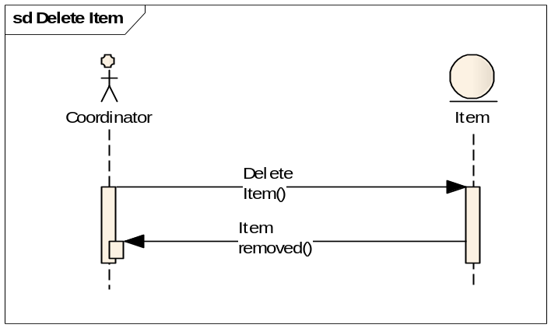

3.2.13.1 Manage Resources Locations

USE CASE # 13 | Manage Resources Locations
Goal in Context | The main resources locations management page that coordinator will manage the resources locations that he have and may use it to store or supplying.
Scope & Level | Company, Summary
Preconditions | -Must the coordinator login
Success End Condition | - The coordinator can manage his resources locations can add, view or edit his resources locations.
Failed End Condition | - Login in failed  - There is No resources locations to manage or supply from it
Primary,  Secondary Actors | Coordinator
Trigger
DESCRIPTION | Step | Action
 | 1 | The coordinator press “Manage Resources Locations”
 | 2 | The coordinator use any function.
 | 3 | The coordinator will manage all resources locations function.
EXTENSIONS | Step | Branching Action
 | 1a | - "Error!" message
SUB-VARIATIONS |  | Branching Action
 | 1 | Coordinator may use some different locations

RELATED INFORMATION | Manage Resources Locations
Priority: | Top
Performance | 5 second to show resources locations functions
Frequency
Channels to actors | Not yet determine
OPEN ISSUES | What is the coordinator cannot manage resources locations?  What is the coordinator cannot use resources locations functions?
Due Date | Release 1.0
...any other
management
information...
Superordinates | Login
Subordinates | Add Location , View Locations

3.2.14.1 Add Location

USE CASE # 14 | Add Location
Goal in Context | Coordinator can add new resources locations and may start to use it in our supply and storing.
Scope & Level | Company , Summary
Preconditions | -Must the coordinator login.
Success End Condition | - The coordinator can add new resource location.
Failed End Condition | - The coordinator cannot add new resource location.
Primary,  Secondary Actors | Coordinator
Trigger | When the coordinator needs to add new resource location.
DESCRIPTION | Step | Action
 | 1 | The coordinator press “Add Location”
 | 2 | The coordinator fills the location form.
 | 3 | The coordinator will save the location.
EXTENSIONS | Step | Branching Action
 | 1a | "Error!" message
SUB-VARIATIONS |  | Branching Action
 |  | May add nearest resources locations.

RELATED INFORMATION | Add Location
Priority: | Top
Performance | 10 minutes for add location
Frequency | 10/day
Channels to actors | not yet determined
OPEN ISSUES | What is the coordinator cannot add new locations?
Due Date | Release 1.0
...any other
management
information...
Superordinates | Manage Resources Locations
Subordinates | None

3.2.14.2 Sequence Diagram
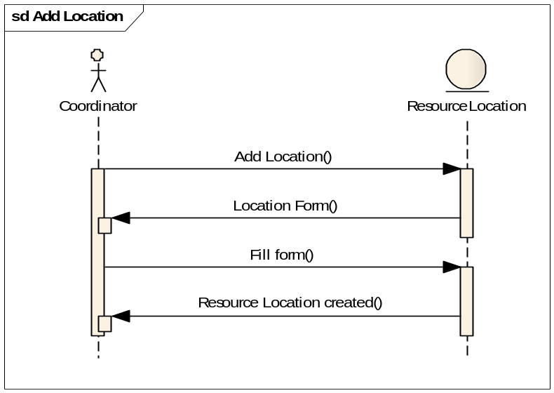

3.2.15.1 View Locations

USE CASE # 15 | View Locations
Goal in Context | The coordinator can view all resources locations that he have, that use to supplying our customer and store our items.
Scope & Level | Company , Summary
Preconditions | -Must the coordinator login
Success End Condition | - The coordinator can view all resources locations.
Failed End Condition | - Login in failed  - The coordinator cannot view all resources locations.
Primary,  Secondary Actors | Coordinator
Trigger | When the coordinator needs to view all locations.
DESCRIPTION | Step | Action
 | 1 | The coordinator press “View Locations”.
 | 2 | The coordinator view list of Locations.
EXTENSIONS | Step | Branching Action
 | 1a | "Error!" message
SUB-VARIATIONS |  | Branching Action
 | 1 | Coordinator may want to see the Locations category
 | 2 | Coordinator may want to see the Locations that nearest to our customer.

RELATED INFORMATION | View Locations
Priority: | Top
Performance | 10 seconds to show the list
Frequency | 10/day
Channels to actors | not yet determined
OPEN ISSUES | What is the coordinator cannot view locations?
Due Date | Release 1.0
...any other
management
information...
Superordinates | Manage Resources Locations
Subordinates | View Locations Details

3.2.15.2 Sequence Diagram
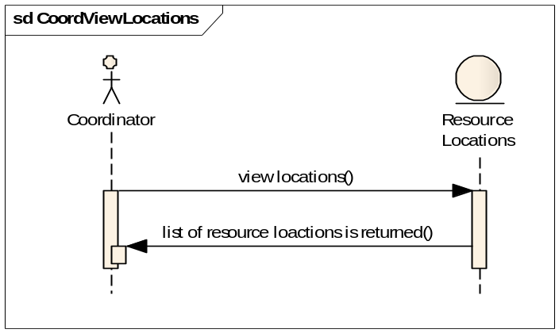

3.2.16.1 View Location Details
USE CASE # 16 | View Location Details
Goal in Context | Coordinator can show the details of resource location that he chooses.
Scope & Level | Company , Summary
Preconditions | -Must the coordinator login.
Success End Condition | - The coordinator can show the details of a location.
Failed End Condition | - The coordinator cannot show the details of a location.
Primary,  Secondary Actors | Coordinator
Trigger | When the coordinator need to view the details of a location.
DESCRIPTION | Step | Action
 | 1 | The coordinator press “View Location Details”
 | 2 | The coordinator views the details of a location.
EXTENSIONS | Step | Branching Action
 | 1a | "Error!" message
SUB-VARIATIONS |  | Branching Action

RELATED INFORMATION | View Location Details
Priority: | middle
Performance | 10 seconds to show the details of a location.
Frequency | 10/day
Channels to actors | not yet determined
OPEN ISSUES | What is the coordinator cannot view the details of a location?
Due Date | Release 1.0
...any other
management
information...
Superordinates | View Locations
Subordinates | Delete Locations, Edit Location

3.2.16.2 Sequence Diagram
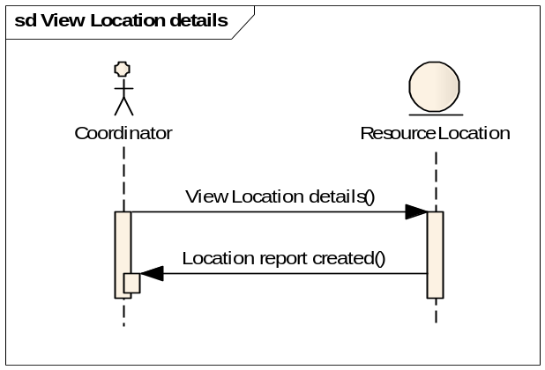

3.2.17.1 Edit Location

USE CASE # 17 | Edit Location.
Goal in Context | The Coordinator can edit a location that he wants.
Scope & Level | Company , Summary
Preconditions | -Must the coordinator login  -The coordinator press “Edit Location”
Success End Condition | - The coordinator can edit exist location.
Failed End Condition | - Login in failed  - The coordinator cannot edit exist location.
Primary,  Secondary Actors | Coordinator
Trigger | When the coordinator needs to edit any exist location.
DESCRIPTION | Step | Action
 | 1 | The coordinator press “Edit Location”
 | 2 | The coordinator modifies the location information.
EXTENSIONS | Step | Branching Action
 | 1a | "Error!" message
SUB-VARIATIONS |  | Branching Action

RELATED INFORMATION | Edit Location
Priority: | Top
Performance | 10 minutes for edit, on time change
Frequency | 10/day
Channels to actors | not yet determined
OPEN ISSUES | What is the coordinator cannot edit any location?
Due Date | Release 1.0
...any other
management
information...
Superordinates | View Locations Details
Subordinates | None

3.2.17.2 Sequence Diagram
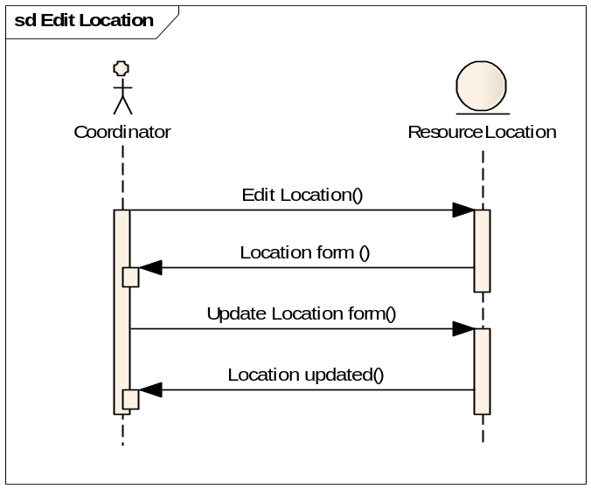

3.2.18.1 Delete Location

USE CASE # 18 | Delete Location
Goal in Context | The Coordinator can delete any location from his list.
Scope & Level | Company , Summary
Preconditions | -Must the coordinator login
Success End Condition | - The coordinator can delete exist location.
Failed End Condition | - Login in failed  - The coordinator cannot delete exist location.
Primary,  Secondary Actors | Coordinator.
Trigger | When the coordinator needs to delete any exist location.
DESCRIPTION | Step | Action
 | 1 | The coordinator press “Delete Location”
 | 2 | The information about the location will show.
 | 3 | Press “Delete” to processing the deleting
EXTENSIONS | Step | Branching Action
 | 1a | "Error!" message
SUB-VARIATIONS |  | Branching Action

RELATED INFORMATION | Delete Location
Priority:
Performance | 1 minute for delete
Frequency | 10/day
Channels to actors | not yet determined
OPEN ISSUES | What is the coordinator cannot delete a location?
Due Date | Release 1.0
...any other
management
information...
Superordinates | View Location Details
Subordinates | None

3.2.18.2 Sequence Diagram
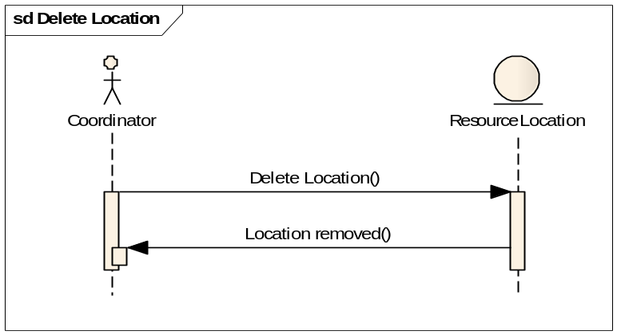

3.2.19.1 Edit Profile

USE CASE # 19 | Edit Profile
Goal in Context | The supplier can edit his profile. The profile contains the name of the supplier, the address, contact person and e-mail… etc.
Scope & Level | Primary Task
Preconditions | - The actor has logged in.
Success End Condition | The supplier profile is updated to the newly entered values.
Failed End Condition | The older profile remains as is. An error message is generated.
Primary,  Secondary Actors | Primary: Supplier  Secondary: Coordinator (by use case Edit Supplier)
Trigger | Clicking on the proper link for editing the profile.
DESCRIPTION | Step | Action
 | 1 | He clicks on the proper link to edit his profile.
 | 2 | Whether he make changes or not, when he clicks on the proper link to submit the profile values, the current values of the profile is saved and he is returned to the main menu.
EXTENSIONS | Step | Branching Action
 | 1a | Invalid input :  Generating error message and discard changes.
SUB-VARIATIONS |  | Branching Action
 |  | none

RELATED INFORMATION | Edit Profile
Priority: | Critical (some functions depend on successfulness of this UC)
Performance | Must not exceed 1 sec to save the new input values.
Frequency | Once every 2-3 months.
Channels to actors | Database.
OPEN ISSUES
Due Date
...any other
management
information...
Superordinates
Subordinates

3.2.19.2 Sequence Diagram
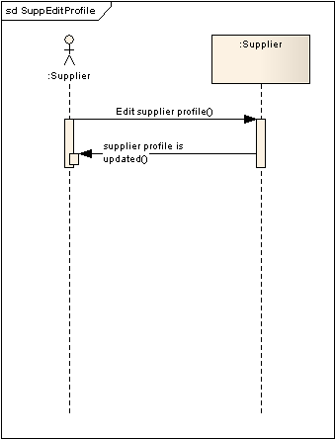

3.2.20.1 View Supply Requests
USE CASE # 20 | View Supply Requests
Goal in Context | To show a list of pending requests.
Scope & Level | Primary Task
Preconditions | - The actor has logged in.
Success End Condition | The list of pending requests is rendered.
Failed End Condition | An error message is generated.
Primary,  Secondary Actors | Primary: Supplier
Trigger | Clicking on the proper link for viewing the supply requests.
DESCRIPTION | Step | Action
 | 1 | He clicks on the proper link to view supply requests.
 | 2 | A list of pending requests is listed.
EXTENSIONS | Step | Branching Action
 | 1a | If there is no requests :  A message is displayed stating that there is no requests.
SUB-VARIATIONS |  | Branching Action

RELATED INFORMATION | View Supply Requests
Priority: | Critical
Performance | Less than 1 second
Frequency | Usually every time the supplier logins to the system. Almost daily.
Channels to actors | Database
OPEN ISSUES
Due Date
...any other
management
information...
Superordinates
Subordinates

3.2.20.2 Sequence Diagram
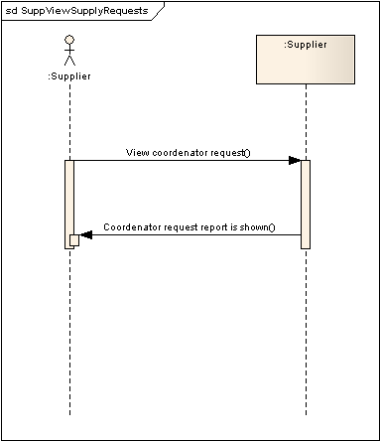

3.2.21.1 View Request Details

USE CASE #21 | View Request Details
Goal in Context | To view extended details of the chosen request.
Scope & Level | Primary Task
Preconditions | - The actor has logged in.
Success End Condition | Details of the chosen request are displayed.
Failed End Condition | An error message is generated.
Primary,  Secondary Actors | Primary: Supplier
Trigger | Clicking on the proper link on a certain displayed request to show its full details.
DESCRIPTION | Step | Action
 | 1 | He clicks on the proper link to view supply requests.
 | 2 | A list of pending requests is listed.
 | 3 | He clicks on the proper link on a request to display its details.
EXTENSIONS | Step | Branching Action
 | 1a | "Error!" message
SUB-VARIATIONS |  | Branching Action
 | 1

RELATED INFORMATION | View Request Details
Priority: | Critical
Performance | Less than 1 second.
Frequency | Usually every time the supplier logins to the system. Almost daily.
Channels to actors | Database
OPEN ISSUES
Due Date
...any other
management
information...
Superordinates
Subordinates | Send Feedback on Request

3.2.21.2 Sequence Diagram
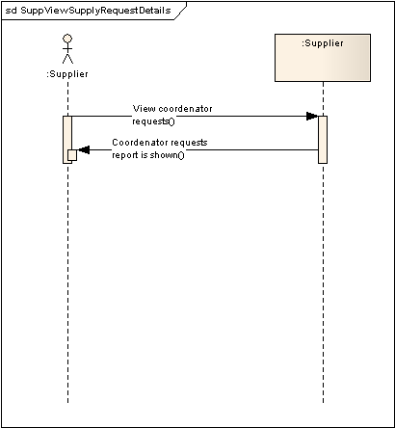

3.2.22.1 Send Feedback on Request

USE CASE #22 | Send Feedback on Request
Goal in Context | The supplier states whether he can supply all the requested items or part of them and the time frame to deliver them.
Scope & Level | Primary Task
Preconditions | - The actor has logged in.  - The actor views a certain request details.
Success End Condition | A message indicating successful submission is generated.
Failed End Condition | An error message is generated.
Primary,  Secondary Actors | Primary: Supplier
Trigger | Clicking on the proper link on a certain displayed request to show its full details.
DESCRIPTION | Step | Action
 | 1 | He input his feedback and submits.
 | 2 | A success (or error) message is displayed.
EXTENSIONS | Step | Branching Action
 | 1a | "Error!" message.
SUB-VARIATIONS |  | Branching Action
 | 1

RELATED INFORMATION | Send Feedback on Request
Priority: | Critical
Performance | Less than 1 second.
Frequency | Usually every time the supplier logins to the system and at least one request exists. Almost daily.
Channels to actors | Database
OPEN ISSUES
Due Date
...any other
management
information...
Superordinates
Subordinates

3.2.21.2 Sequence Diagram
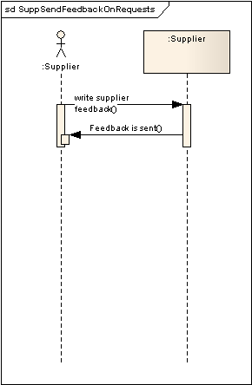

3.2.23.1 Edit Profile

USE CASE # 23 | Edit Profile
Goal in Context | The customer can edit his profile. The profile contains the name of the customer, his address, contact person and e-mail… etc.
Scope & Level | Primary Task
Preconditions | - The actor has logged in.
Success End Condition | The customer profile is updated to the newly entered values.
Failed End Condition | The older profile remains as is. An error message is generated.
Primary,  Secondary Actors | Primary: Customer  Secondary: Coordinator (by use case Edit Customer)
Trigger | Clicking on the proper link for editing the profile.
DESCRIPTION | Step | Action
 | 1 | He clicks on the proper link to edit his profile.
 | 2 | Whether he makes changes or not, when he clicks on the proper link to submit the profile values, the current values of the profile is saved and he is returned to the main menu.
EXTENSIONS | Step | Branching Action
 | 1a | Invalid input :  Generating error message and discard changes.
SUB-VARIATIONS |  | Branching Action
 |  | none

RELATED INFORMATION | Edit Profile
Priority: | Critical (some functions depend on successfulness of this UC)
Performance | Must not exceed 1 sec to save the new input values.
Frequency | Once every 2-3 months.
Channels to actors | Database.
OPEN ISSUES
Due Date
...any other
management
information...
Superordinates
Subordinates

3.2.23.2 Sequence Diagram
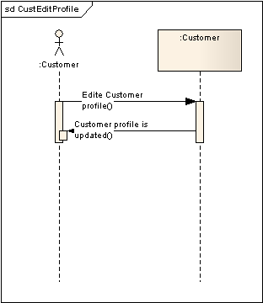

3.2.24.1 Add Request

USE CASE #24 | Add Request
Goal in Context | Customer can add new request.
Scope & Level | Company , Summary
Preconditions | -The Customer has logged in.
Success End Condition | - A new request is added.
Failed End Condition | An error message is generated and the request is discarded.
Primary,  Secondary Actors | Customer , Coordinator
Trigger | When the Customer clicks on the proper link for adding a request.
DESCRIPTION | Step | Action
 | 1 | The Customer press “Add Request”
 | 2 | The Customer fills the request form.
 | 3 | The Customer will send the request to the Coordinator.
EXTENSIONS | Step | Branching Action
 | 1a | "Error!" message
SUB-VARIATIONS |  | Branching Action
 | 1 | Customer may use phone to request from Coordinator. The Coordinator, then, adds the request manually.

RELATED INFORMATION | Add Request
Priority: | Top
Performance | 10 minutes for request, 2 days until accept
Frequency | 10/day
Channels to actors | not yet determined
OPEN ISSUES | What if the Customer cannot add new requests?
Due Date | Release 1.0
...any other
management
information...
Superordinates | Requests Management
Subordinates | None

3.2.24.2 Sequence Diagram
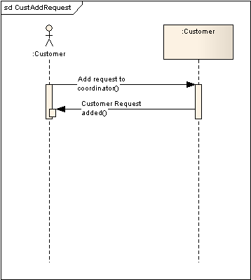

3.2.25.1 View Requests
USE CASE #25 | View Requests
Goal in Context | Customer can view all his pending requests that were sent to the Coordinator.
Scope & Level | Company , Summary
Preconditions | -The Customer has logged in.
Success End Condition | - The Customer views all requests.
Failed End Condition | An error message is generated and the request is discarded.
Primary,  Secondary Actors | Customer, Coordinator.
Trigger | When the Customer clicks on the proper link for adding a request.
DESCRIPTION | Step | Action
 | 1 | The Customer press “View Requests”
 | 2 | The Customer view list of requests.
EXTENSIONS | Step | Branching Action
 | 1a | "Error!" message
SUB-VARIATIONS |  | Branching Action
 | 1 | Customer may want to refine viewed request on certain criteria.
 | 2 | Customer may want to see some older requests.

RELATED INFORMATION | View Requests
Priority: | Top
Performance | 3 seconds to show the list
Frequency | 10/day
Channels to actors | not yet determined
OPEN ISSUES | What is the coordinator cannot view requests?
Due Date | Release 1.0
...any other
management
information...
Superordinates | Manage Requests
Subordinates | - Delete Request  - Edit Request

3.2.25.2 Sequence Diagram
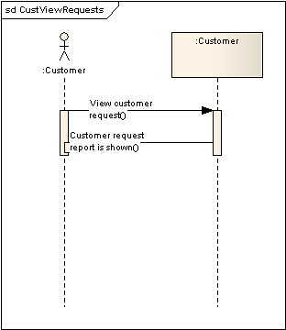

3.2.27.1 Edit Request

USE CASE # 27 | Edit Request
Goal in Context | The Customer can edit request and notify the Coordinator.
Scope & Level | Company , Summary
Preconditions | -The Customer has logged in.
Success End Condition | - The chosen request is edited.  - The notification will send to the coordinator.
Failed End Condition | An error message is generated and the request is discarded.
Primary,  Secondary Actors | Customer, Coordinator
Trigger | When the Customer clicks on the proper link for editing a request.
DESCRIPTION | Step | Action
 | 1 | The Customer press “Edit Request”
 | 2 | The Customer modifies the request information.
 | 3 | A notification will be sent to the Coordinator.
EXTENSIONS | Step | Branching Action
 | 1a | "Error!" message
SUB-VARIATIONS |  | Branching Action
 | 1 | Coordinator may use phone to request from suppliers

RELATED INFORMATION | Edit Request
Priority: | Top
Performance | 10 minutes for edit, on time change
Frequency | 10/day
Channels to actors | not yet determined
OPEN ISSUES | - What if the Customer cannot edit any request?  - Shouldn't we disable editing requests whenever they are acknowledged by the Coordinator?
Due Date | Release 1.0
...any other
management
information...
Superordinates | View Request Details
Subordinates | None

3.2.27.2 Sequence Diagram
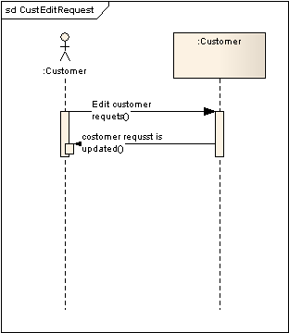

3.2.28.1 Delete Request

USE CASE #28 | Delete Request
Goal in Context | The Coordinator can delete request and notify his supplier
Scope & Level | Company , Summary
Preconditions | -The Customer has logged in.
Success End Condition | - The Customer can delete a chosen request.  - The notification will be sent to the Coordinator.
Failed End Condition | An error message is generated.
Primary,  Secondary Actors | Customer, Coordinator
Trigger | When the Customer clicks on the proper link for deleting a request.
DESCRIPTION | Step | Action
 | 1 | The Customer press “Delete Request”
 | 2 | The information about the request will show.
 | 3 | Press “Delete” to processing the deleting
 | 4 | The Customer will send a notification to supplier
EXTENSIONS | Step | Branching Action
 | 1a | "Error!" message
SUB-VARIATIONS |  | Branching Action
 | 1 | Customer may use phone to delete the request by the Coordinator.

RELATED INFORMATION | Delete Request
Priority:
Performance | 5 seconds for delete
Frequency | 10/day
Channels to actors | not yet determined
OPEN ISSUES | What is the coordinator cannot delete requests?
Due Date | Release 1.0
...any other
management
information...
Superordinates | View Request Details
Subordinates | None

3.2.28.2 Sequence Diagram
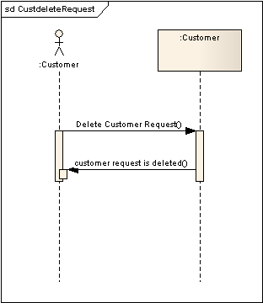

3.2.29.1 Manage Customers

USE CASE # 29 | Manage Customers
Goal in Context | The main customers management page that coordinator will manage all customers information
Scope & Level | Company, Summary
Preconditions | -Must the coordinator login
Success End Condition | - The coordinator should add ,view, edit or delete customers
Failed End Condition | An error message is generated.
Primary,  Secondary Actors | Coordinator , Customer
Trigger
DESCRIPTION | Step | Action
 | 1 | The coordinator press “Manage Customers”
 | 2 | The coordinator use any function.
 | 3 | The coordinator will manage all customers function.
EXTENSIONS | Step | Branching Action
 | 1a | - "Error!" message
SUB-VARIATIONS |  | Branching Action

RELATED INFORMATION | Manage Customers
Priority: | Top
Performance
Frequency
Channels to actors
OPEN ISSUES | What if the coordinator cannot manage cutomers?
Due Date | Release 1.0
...any other
management
information...
Superordinates | Login
Subordinates | Add Customer , View Customers

3.2.30.1 Add Customer

USE CASE #30 | Add Customer
Goal in Context | Coordinator can add new Customer.
Scope & Level | Company , Summary
Preconditions | -Must the coordinator login  -The coordinator press “Add Customer”
Success End Condition | - The coordinator can add new customer.
Failed End Condition | - Login in failed  - An error message is generated.
Primary,  Secondary Actors | Coordinator , Cutomer
Trigger | When the coordinator needs to add new customer.
DESCRIPTION | Step | Action
 | 1 | The coordinator press “Add Customer”
 | 2 | The coordinator fills the new customer form.
 | 3 | The coordinator will send the customer to supplier
EXTENSIONS | Step | Branching Action
 | 1a | "Error!" message
SUB-VARIATIONS |  | Branching Action

RELATED INFORMATION | Add Customer
Priority: | Top
Performance | 1 minutes for request, 2 days until accept
Frequency | 10/day
Channels to actors | not yet determined
OPEN ISSUES | What is the coordinator cannot add new customer?
Due Date | Release 1.0
...any other
management
information...
Superordinates | Customers Management
Subordinates | None

3.2.30.2 Sequence Diagram:
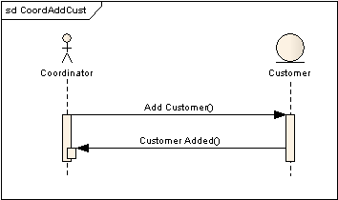

3.2.31.1 View Customers

USE CASE #31 | View Customers
Goal in Context | coordinator can view a list of all customers.
Scope & Level | Company , Summary
Preconditions | -Must the coordinator login
Success End Condition | - The coordinator can show all customers.
Failed End Condition | - Login in failed  - The coordinator cannot view all customers.
Primary,  Secondary Actors | Coordinator , Customer
Trigger | When the coordinator needs to view customers and clicks on the proper link to that function.
DESCRIPTION | Step | Action
 | 1 | The coordinator press “View Customers”
 | 2 | The coordinator view list of customers.
EXTENSIONS | Step | Branching Action
 | 1a | "Error!" message
SUB-VARIATIONS |  | Branching Action
 | 1 | Coordinator may want to see refined list on certain criteria only.

RELATED INFORMATION | View Customers
Priority: | Top
Performance | 10 seconds to show the list
Frequency | 10/day
Channels to actors | not yet determined
OPEN ISSUES | What if the coordinator cannot view customers?
Due Date | Release 1.0
...any other
management
information...
Superordinates | Manage Customers
Subordinates | View Customer Details

3.2.31.2 Sequence Diagram:

3.2.32.1 View Customer Details

USE CASE #32 | View Customer Details
Goal in Context | Coordinator can show the details of any customer that he chose.
Scope & Level | Company , Summary
Preconditions | -Must the coordinator login  -The coordinator press “View Customer Details”
Success End Condition | - The coordinator can show the details of a customer.
Failed End Condition | - The coordinator cannot show the details of a customer.
Primary,  Secondary Actors | Coordinator , Customer
Trigger | When the coordinator need to view the details of a customer.
DESCRIPTION | Step | Action
 | 1 | The coordinator press “View Customer Details”
 | 2 | The coordinator views the details of a customer.
EXTENSIONS | Step | Branching Action
 | 1a | "Error!" message
SUB-VARIATIONS |  | Branching Action

RELATED INFORMATION | View Customer Details
Priority: | Middle
Performance | 10 seconds to show the details of a customer.
Frequency | 10/day
Channels to actors | not yet determined
OPEN ISSUES | What is the coordinator cannot view the details of a customer?
Due Date | Release 1.0
...any other
management
information...
Superordinates | View Customers
Subordinates | Delete Customer, Edit Customer

3.2.31.2 Sequence Diagram:
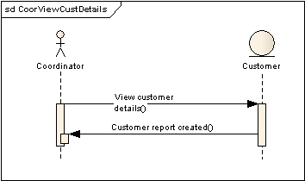

3.2.33.1 Edit Customer

USE CASE # 33 | Edit Customer
Goal in Context | The Coordinator can edit customer him.
Scope & Level | Company , Summary
Preconditions | -Must the coordinator login
Success End Condition | - The coordinator can edit exist customer.
Failed End Condition | - Login in failed  - An error message is generated.
Primary,  Secondary Actors | Coordinator , Customer
Trigger | When the coordinator needs to edit any exist customer.
DESCRIPTION | Step | Action
 | 1 | The coordinator press “Edit Customer”
 | 2 | The coordinator modifies the request information.
 | 3 | The coordinator will send a notification to the customer.
EXTENSIONS | Step | Branching Action
 | 1a | "Error!" message
SUB-VARIATIONS |  | Branching Action

RELATED INFORMATION | Edit Customer
Priority: | Top
Performance | 1 minutes for edit, on time change
Frequency | 10/day
Channels to actors | not yet determined
OPEN ISSUES | What if the Coordinator cannot edit any customer?
Due Date | Release 1.0
...any other
management
information...
Superordinates | ViewCustomer Details
Subordinates | None

3.2.33.2 Sequence Diagram
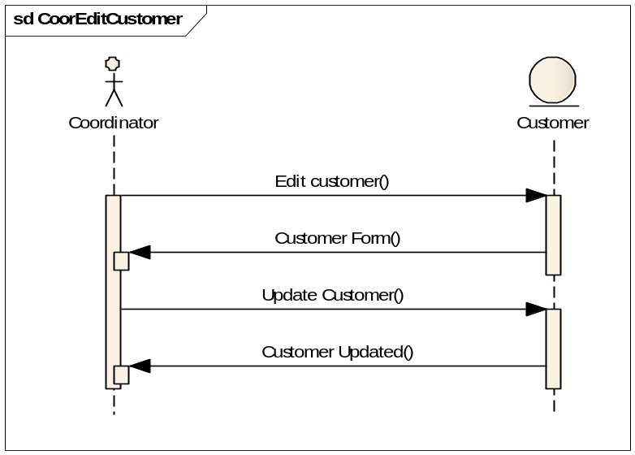

3.2.34.1 Delete Customer

USE CASE #34 | Delete Customer
Goal in Context | The coordinator can delete a certain customer
Scope & Level | Company , Summary
Preconditions | -Must the coordinator login
Success End Condition | - The coordinator can delete exist customer.  - The customer will be notified by option.
Failed End Condition | - Login in failed  - An error message is generated.
Primary,  Secondary Actors | Coordinator , Customer
Trigger | When the coordinator needs to delete any exist customer.
DESCRIPTION | Step | Action
 | 1 | The coordinator press “Delete Customer”
 | 2 | The information about the customer will show.
 | 3 | Press “Delete” to processing the deleting
 | 4 | The coordinator will send a notification to the customer on option.
EXTENSIONS | Step | Branching Action
 | 1a | "Error!" message
SUB-VARIATIONS |  | Branching Action

RELATED INFORMATION | Delete Customer
Priority:
Performance | 1 minute for delete
Frequency | 10/day
Channels to actors | not yet determined
OPEN ISSUES | What is the coordinator cannot delete customer?
Due Date | Release 1.0
...any other
management
information...
Superordinates | View Customer Details
Subordinates | None

3.2.34.2 Sequence Diagram
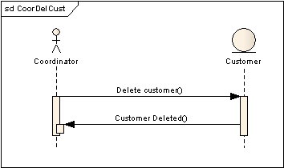

3.2.35.1 Manage Suppliers

USE CASE # 35 | Manage Suppliers
Goal in Context | The main suppliers management page that coordinator will manage all suppliers information
Scope & Level | Company, Summary
Preconditions | -Must the coordinator login
Success End Condition | - The coordinator should add ,view, edit or delete his suppliers.
Failed End Condition | An error message is generated.
Primary,  Secondary Actors | Coordinator , Supplier
Trigger
DESCRIPTION | Step | Action
 | 1 | The coordinator press “Manage Suppliers”
 | 2 | The coordinator use any function.
 | 3 | The coordinator will manage all suppliers function.
EXTENSIONS | Step | Branching Action
 | 1a | - "Error!" message
SUB-VARIATIONS |  | Branching Action

RELATED INFORMATION | Manage Suppliers
Priority: | Top
Performance
Frequency
Channels to actors
OPEN ISSUES | What if the coordinator cannot manage suppliers?
Due Date | Release 1.0
...any other
management
information...
Superordinates | Login
Subordinates | Add Supplier, View Supplier

3.2.36.1 Add Supplier

USE CASE #36 | Add Supplier
Goal in Context | Coordinator can add new Supplier
Scope & Level | Company , Summary
Preconditions | -Must the coordinator login
Success End Condition | - The coordinator can add new Supplier.
Failed End Condition | - Login in failed  - An error message is generated.
Primary,  Secondary Actors | Coordinator , Supplier
Trigger | When the coordinator needs to add new Supplier.
DESCRIPTION | Step | Action
 | 1 | The coordinator press “Add Supplier”
 | 2 | The coordinator fills the new Supplier form.
 | 3 | The coordinator will send the Supplier to supplier
EXTENSIONS | Step | Branching Action
 | 1a | "Error!" message
SUB-VARIATIONS |  | Branching Action

RELATED INFORMATION | Add Supplier
Priority: | Top
Performance | 1 minutes for application, 2 days until accept
Frequency | 10/day
Channels to actors | not yet determined
OPEN ISSUES | What is the coordinator cannot add new Supplier?
Due Date | Release 1.0
...any other
management
information...
Superordinates | Suppliers Management
Subordinates | None

3.2.36.2 Sequence Diagram

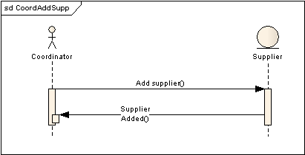

3.2.37.1 View Suppliers

USE CASE #37 | View Suppliers
Goal in Context | coordinator can view a list of all Suppliers.
Scope & Level | Company , Summary
Preconditions | -Must the coordinator login
Success End Condition | - The coordinator can show all Supplier.
Failed End Condition | - Login in failed  - The coordinator cannot view all Suppliers.
Primary,  Secondary Actors | Coordinator , Supplier
Trigger | When the coordinator needs to view Suppliers and clicks on the proper link to that function.
DESCRIPTION | Step | Action
 | 1 | The coordinator press “View Suppliers”
 | 2 | The coordinator view list of Suppliers.
EXTENSIONS | Step | Branching Action
 | 1a | "Error!" message
SUB-VARIATIONS |  | Branching Action
 | 1 | Coordinator may want to see refined list on certain criteria only.

RELATED INFORMATION | View Suppliers
Priority: | Top
Performance | 10 seconds to show the list
Frequency | 10/day
Channels to actors | not yet determined
OPEN ISSUES | What if the coordinator cannot view Suppliers?
Due Date | Release 1.0
...any other
management
information...
Superordinates | Manage Suppliers
Subordinates | View Supplier Details

3.2.37.2 Sequence Diagram
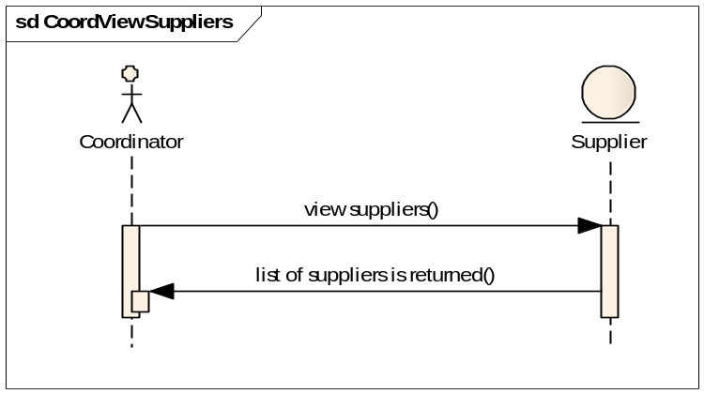

3.2.38.1 View Supplier Details

USE CASE #38 | View Supplier Details
Goal in Context | Coordinator can show the details of any Supplier that he chose.
Scope & Level | Company , Summary
Preconditions | -Must the coordinator login  -The coordinator press “View Supplier Details”
Success End Condition | - The coordinator can show the details of a Supplier.
Failed End Condition | - The coordinator cannot show the details of a Supplier.
Primary,  Secondary Actors | Coordinator , Supplier
Trigger | When the coordinator need to view the details of a Supplier.
DESCRIPTION | Step | Action
 | 1 | The coordinator press “View Supplier Details”
 | 2 | The coordinator views the details of a Supplier.
EXTENSIONS | Step | Branching Action
 | 1a | "Error!" message
SUB-VARIATIONS |  | Branching Action

RELATED INFORMATION | View Supplier Details
Priority: | Middle
Performance | 10 seconds to show the details of a Supplier.
Frequency | 10/day
Channels to actors | not yet determined
OPEN ISSUES | What is the coordinator cannot view the details of a Supplier?
Due Date | Release 1.0
...any other
management
information...
Superordinates | View Supplier
Subordinates | Delete Supplier, Edit Supplier

3.2.38.2 Sequence Diagram:
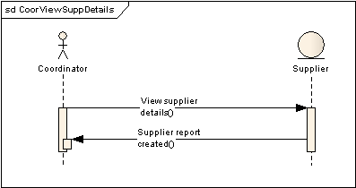

3.2.39.1 Edit Supplier

USE CASE # 39 | Edit Supplier
Goal in Context | The Coordinator can edit Supplier and notify him (on option.)
Scope & Level | Company , Summary
Preconditions | -Must the coordinator login
Success End Condition | - The coordinator can edit exist Supplier.
Failed End Condition | - Login in failed  - An error message is generated.
Primary,  Secondary Actors | Coordinator , Supplier
Trigger | When the coordinator needs to edit any exist Supplier.
DESCRIPTION | Step | Action
 | 1 | The coordinator press “Edit Supplier”
 | 2 | The coordinator modifies the Supplier information.
 | 3 | The coordinator will send a notification to the Supplier.
EXTENSIONS | Step | Branching Action
 | 1a | "Error!" message
SUB-VARIATIONS |  | Branching Action

RELATED INFORMATION | Edit Supplier
Priority: | Top
Performance | 1 minutes for edit, on time change
Frequency | 10/day
Channels to actors | not yet determined
OPEN ISSUES | What if the Coordinator cannot edit any Supplier?
Due Date | Release 1.0
...any other
management
information...
Superordinates | View Supplier Details
Subordinates | None

3.2.39.2 Sequence Diagram

3.2.40.1 Delete Supplier

USE CASE #40 | Delete Supplier
Goal in Context | The coordinator can delete a certain Supplier
Scope & Level | Company , Summary
Preconditions | -Must the coordinator login
Success End Condition | - The coordinator can delete exist Supplier.  - The Supplier will be notified by option.
Failed End Condition | - Login in failed  - An error message is generated.
Primary,  Secondary Actors | Coordinator , Supplier
Trigger | When the coordinator needs to delete any exist Supplier.
DESCRIPTION | Step | Action
 | 1 | The coordinator press “Delete Supplier”
 | 2 | The information about the customer will show.
 | 3 | Press “Delete” to processing the deleting
 | 4 | The coordinator will send a notification to the Supplier on option.
EXTENSIONS | Step | Branching Action
 | 1a | "Error!" message
SUB-VARIATIONS |  | Branching Action

RELATED INFORMATION | Delete Supplier
Priority:
Performance | 1 minute for delete
Frequency | 10/day
Channels to actors | not yet determined
OPEN ISSUES | What is the coordinator cannot delete Supplier?
Due Date | Release 1.0
...any other
management
information...
Superordinates | View Supplier Details
Subordinates | None

3.2.40.2 Sequence Diagram
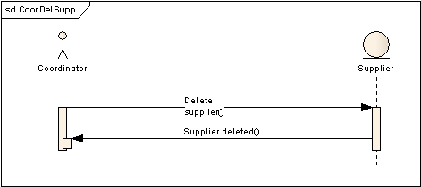
3.3 Performance Requirements
The system must handle at least 100 concurrent users and their operations. The system must accomplish 90% for transactions in less than 1 second. This is due to the nature of data, which is only text information that does not usually exceed 50 KB per transaction.

3.4 Logical Database Requirements
The DB tables shall reflect following:
- Coordinator
- Customer
- Supplier
- Resource Location
- Item
- Request

3.5 Design Constraints

3.5.1 Programming language:
Our System will be web based system which we will use a web developing language. We will use ASP.NET and C# languages. The system has to be designed on .NET Framework 3.5 using Visual Studio family.

3.5.2 Database:
The system will use MS SQL for our database.

3.5.3 Software Process:
The system shall follow the Waterfall software process model. Also the system shall be designed in an Object Oriented approach so that future features can be easily integrated with the system.

3.5.4 Ejada framework:
The system has to use the Ejada .Net frame work and also our system will integrate with two modules in Ejada.

3.6 Software System Attributes

3.6.1 Reliability
All data will be backed-up everyday automatically and also the system administrator can back-up the data as a function for him. Also if any errors, fault or failures happen the system will detected and inform the user about problems and also if there is any transaction with the database and in that time happen no action to the data and the system will back to the previous state of database. Also our system will cover the quality assurance.

3.6.2 Availability
The system has to be available 100% of the time. Once there is a fatal error, the system should give understandable feedback to the user.

3.6.3 Security

The system have only three roles for coordinators , suppliers and customers only that make our system secure access online and these authentications will prevent and illegal access.

3.6.4 Maintainability

The system is designed in modules where errors can be detected and fixed easily. This makes it easier to install updates and new functionality if required.

3.6.5 Portability

The system can operate in any of the latest Microsoft operating systems with the latest .Net framework. Due to the web based nature of the system, the host machine must also have Microsoft IIS installed

4. Change Management Process

Every change in the SRS will be done by the developing team and it is updated in the SRS review report which contains all the information of the change shush as change date, author, the change is applied on what , and why the changed is applied.
Appendix

Use Case Diagrams
